COP 4640 – Operating System Environments and Administration

Mike Jurendic

Eric Netland

Nicolas Martinez

Guneet Jandir

Cody Pafford

**The Lynx You Never Xpected**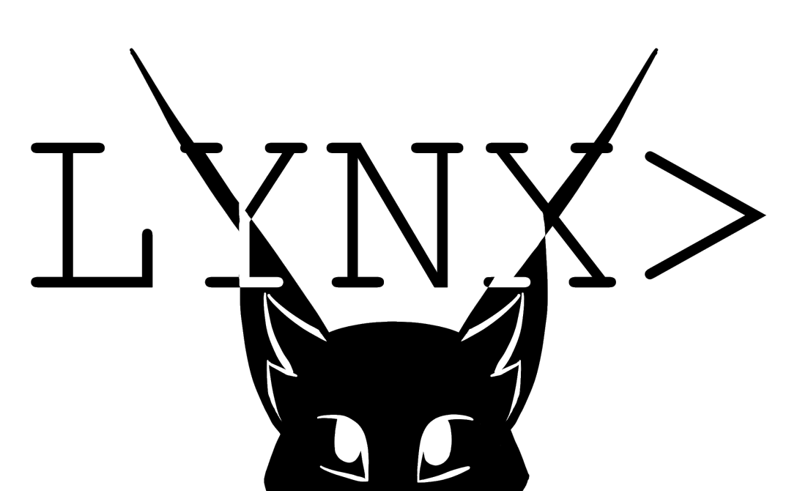

**State of Research**

The team is, for the most part, happy with the state of research. We are experiencing some confusion in finding sufficient references for our assigned topics but have managed to preserve so far. We have been keeping up to date with the milestones, but a mistake was made in planning ahead. We failed to take into account that the conclusion and future developments would not be a part of this deliverable and as a result the three team members working on the introduction to the operating systems, Eric, Guneet and Nicolas, were left with more work on accident. Fortunately, the work will even out once again once work on the rough draft begins as the introduction work will already be finished. Cody and Mike will now have their fair share of ‘extras’ to do for the rough draft. (The future developments and conclusion respectively)

After reviewing the requirements for the rough draft, we expect we should have no further complications for producing a near-perfect rough draft by the due date.

**Introduction**

**History and evolution of windows**

When it comes to operating systems, the first one that comes to most people’s minds is windows. Windows in the span of over 35 years has gone through 10 different versions from 1 to 10. Windows one came out in the year 1985, created by Bill Gates. It was Microsoft’s first attempt at a graphical user interface in 16-bit. It was notable because it relied heavy on mouse use and helped create reliance on the mouse for navigation instead of key commands. Windows 2 brought in the ability to overlap windows, the ability to minimize and maximize windows, the control panel, and Microsoft word and excel. Windows 3 was the first windows requiring the use of a hard drive and the first version to become more widely used by the public. Windows 3 brought with it the ability to run MS-DOS programs, giving it the ability to multitask legacy programs. But most importantly introduced the game Solitaire to the world. The first windows to be introduced on a CD-ROM was windows 3.1. It required at least 1MB of RAM to run and had support for mouse use in MS-DOS. In 1995 as you may have guessed it, Windows 95 was released. 95 brought with it the Start Button and Menu alongside the task bar and focused multitasking. This is also when the world's most hated web browser was released, or some call it “the google chrome downloader”. Building upon 95, windows 98 was released three years later. It came with much more software like Internet explorer, outlook, address book, and Windows Media Player. But the most important change was the windows driver model for components and accessories, the one driver support for all future versions of windows. The last windows to be based on MS-DOS was Windows ME and Windows 2000. Windows ME was meant to be more consumer friendly while 2000 was meant to be more business oriented. ME introduced important concepts to user like automated system recovery tools. But sadly, windows ME was notoriously buggy and many times failed to install properly. Windows ME was followed by possibly one of the greatest OS’s of our time, Windows XP. Windows XP did everything that ME wanted and better. It was vastly more visually appealing and developed on. XP lasted from 2001 to 2014 lasting 13 years making it the longest lasting windows ever. With its many successes it had one flaw and that was security. This led Bill Gates to start his “Trustworthy Computing” initiative and added issued service pack for XP making it more secure. XP was followed by windows vista which brought DirectX 10 giving a boost to PC gamers. Vista was not very liked by many users due to its many bugs and was quickly replaced by windows 7. Windows 7 was faster, more stable, and easier to use then vista. Due to the increased popularity of iPads and smartphones Microsoft decided to overhaul Windows. Windows 8 interface was completely changed and look more like a smartphone interface. It was made to be more touch screen friendly. Microsoft released an update to windows 8 which made it more friendly for mouse and keyboard users. Windows 8 was followed by a more keyboard and mouse friendly windows 10. Windows 10 was made to be used by both desktop users and tablet users [3]. 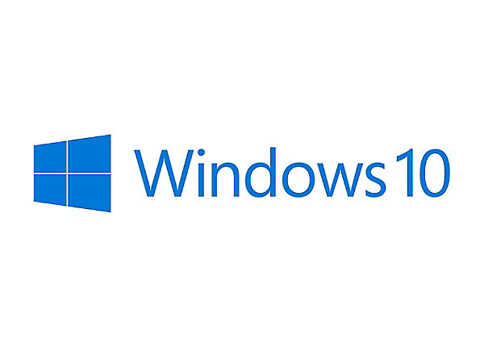

**History and evolution of Linux**

Linux is also an incredibly popular operating system. Mostly because of its large support base and distribution. It was created by Linus Torvalds at the university of Helsinki while studying computer science. Linus was not happy with the MS-DOS operating system and wanted to use a UNIX based system instead but was unable to afford it. This led him to gather a group of 100 developers to create a Unix like operating system from scratch and release Linux in 1994. Linux is an open source software that developers enjoy working on and have made many improvements. Thousands of developers have contributed to the growth of Linux. This has led to the creation of Linux distributions. One such distribution is Ubuntu Linux, which was released in 2004. It is updated every six months and has support for nine months. Ubuntu has three editions desktop, server, and core editions. The desktop edition is as user friendly as windows. It comes with many different apps like Spotify, Firefox, and skype [Edu]. Linux started off only being popular with hobbyists and used on supercomputers but soon Dell, IBM and Hewlett-Packard started offering Linux support to curb the Windows monopoly. But Linux’s largest success may be the mobile market. The Android OS is based on the Linux kernel making it a Linux Distribution [4].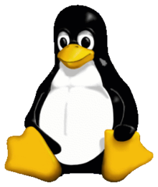

**Key Features of Windows 10**

Windows 10 offers a lot of features that provide ease of use for users. One way this is done is through their start menu which now has 2 columns and contains apps and buttons that are frequently used by the user [LAM]. This is a big improvement from Windows 8.1 which mostly consisted of increased touch screen functions. To assist even further, it also has a voice-controlled agent that can operate the computer through voice commands commonly referred to as Cortana [17]. This allows for increased ease of use as well as allow more people to use computers such as people who are blind. Accompanied with Cortana, Windows 10 also contains a new web browser that is integrated with the new assistant. This allows for access to the internet and its web browsers through voice. Another big new feature of Windows 10 is Virtual Desktops which allows users to create more than one desktop and switch between them on the fly. This is a new highly useful tool that adds even more quality of life changes inside of Windows 10.

**Key Features of Ubuntu Linux**

One of the great features of Ubuntu Linux is its ability to be highly customizable [15]. Just about everything can be changed, even the graphical user interface. This flexibility is what allows Linux to be changed and used across a lot of platforms and is not limited to just desktop computers or laptops. To go further into customization, Linux allows for users to control the entire base system. One reason this is possible is due to it being in modular pieces or pieces of code that are independent of each other [15]. This even allows users to interchange compilers with new ones that better suit them. Not only is it a very customizable operating system, it also runs a lot faster than other operating systems due to it being a light operating system that doesn’t require a lot of processing power.

**Key Limitations of Windows 10**

There are many great things about Windows 10, however these features come at a cost. The size of Windows 10 can range from 25GB to 40 GB. This is quite massive when compared to other operating systems like Linux which are 2GB in size. This makes it hard for Windows 10 to be on any small machinery or robots because they can’t have great enough hardware to run the operating system, let alone the programs they require to function. This limits Windows 10 to powerful devices that have leeway in resources. As mentioned before this is a major negative when resources are limited.

**Key Limitations of Ubuntu Linux**

A big disadvantage of Ubuntu Linux is that using it is very hard when compared to the highly user-friendly Windows 10. Modifying and changing Linux is a plus, but it requires the know how of the users to be at a higher level than the average Windows 10 user. Due to it not being a beefy operating system, support for modern video games on Linux is almost non-existent[8]. Entertainment is not a thing this operating system is good for. This can be attributed to it not having the best driver support out there.

**Current and Historical Market Shares**

In a world where personal computers are in every business, home, and school, operating system choice is a huge factor in how people interact with their devices. Nowadays, it is far from difficult to find personal computers that run Windows 10, considering it holds nearly 40 percent of the market share for desktop operating systems: the most of any desktop operating system on the market [7]. Windows operating systems have become a household name and it seems as though this will continue to be true for a while. Devices today such as affordable laptops are being marketed and sold with Windows 10 installed on them, which helps maintain its large market share [7]. Students and families are likely to buy these devices and become comfortable with Windows 10 since the devices it is installed on are more accessible. Despite having quite a ways to go before winning over the same number of desktop users as Windows 10, Ubuntu Linux is doing surprisingly well for itself outside of the desktop market as it takes on the cloud [16]. Ubuntu is powerful and versatile, especially for cloud deployments in large businesses including, but not limited to, Walmart, Netflix, Snapchat, and Uber [16]. Windows 10 may have a larger number of desktop users, but Ubuntu is by no means falling behind in business. Even outside the desktop market, Tianhe-2, a supercomputer project supported by funds from the Chinese government, runs Ubuntu [16]. However, the needs of the user are a large part in deciding what operating system is best for a computer, and Windows 10, following suit with its predecessors, is well-known and widespread among desktop users. Although there are far fewer supercomputers than desktop computers in the world, it says quite a lot about an operating system when it is selected to run a supercomputer!

This paper will focus on five separate sections which are important parts of an operating system. We will examine each operating system’s similarity and difference to the other to help gain a better understanding of which operating system is suitable for what situation.

***Memory Management*** starts with main memory also known as RAM. Computers are only able to make changes to data that is in main memory. Therefore, all programs and executables must be copied from a storage device into main memory to be executable. Many times, only the required part of a program is loaded into main memory. This is called Dynamic Loading, which is a technique that enhances the performance of the computer. But sometimes there is not enough main memory available to execute all currently active programs. This is where swapping comes in and takes excess processes and moves them onto a disk and brought back in when needed. Different operating systems handle memory management in different ways. We will take a look into how Windows and Linux handle memory management differently in the proposed content below.

***Process management*** has the very intricate task of allocating a single CPU effectively among all of the system’s users and all of their jobs, processes, and threads [MCH]. To keep the computer running smooth, this involves tasks such as the creation of processes, scheduling of new processes, and the termination of processes. Some computers have more than one processor (CPU) and the operating system in this case would have extra work to do to effectively manage the processes in all CPUs. However, most processors today are multi-core meaning enhanced performance, reduced power consumption and more efficient simultaneous processing of multiple tasks [ROU]. For example, if a computer has four cores, then it can process four sets of instructions at the same time. The process manager is responsible for handling all of this as it is a composite of at least two other sub-managers: the Job Scheduler and the Process Scheduler which is responsible for job scheduling and process scheduling, respectively. The Process Scheduler determines which processes will get the CPU, when, and for how long. The Process Scheduler relies on scheduling algorithms in an attempt to allocate the CPU in the best way possible for moving jobs in and out of the system effectively [MCH]. In a batch environment, we also have the influence of priority scheduling which gives priority to certain jobs that are present in the background. This guarantees that the programs with the highest priority are executed first. When people use the computer, they often think that the computer is executing multiple tasks simultaneously such as loading the photos in a browser all at once or playing a PC game while browsing the web. But what most people fail to realize is that even with a single CPU, the computer is actually doing billions of executions per second which ultimately gives the illusion of multiple processes being processed at once. However, the exact amount of executions per second would depend on the clock rate of the CPU.

***Networking Technologies*** are critical to operating systems in modern times. They allow computers using the operating system to create networks for a business like LANs, link to personal devices (PANs) and allow them to connect to the internet. Operating Systems like Linux Ubuntu and Windows 10 has built in software which implements TCP/IP protocols, ping [14].

***System Management*** is essential to ensure the efficiency of an operating system and maximal use of the resources available to it. Not all computers are used or configured in the same way, but each situation calls for a flexible framework that will allow an operating system to be effective regardless. Windows 10 and Ubuntu Linux both take a unique approach to each of the several aspects of system management, each approach exhibiting its own advantages and disadvantages. Disk management in Ubuntu, for example, is handled very differently than it is in Windows 10 [UND]. The use case of each operating system sometimes determines the features it requires, which also contributes to which optimizations are supported on them. Windows 10 leverages its available hardware differently than Ubuntu Linux may, and the customization both allow the end user distinguishes the one operating system’s system management from the other. Like all modern desktop operating systems, however, both have to tackle challenges like handling virtual memory, cache memory, and system booting.

***Concurrent Processing*** is a great tool that applications can use to boost their effectiveness and even solve problems more efficiently as opposed to sequentially operated applications. This is done by parallelism and is greatly enhanced by computers with multiple core processors [SHI]. Operating Systems play a key role in how optimal concurrent processing is because they are what provide communication between the application the cores of the processor. The two operating systems that are being compared show two different solutions to achieve the same goal. Ubuntu Linux shows that it doesn’t require much change at all and takes advantage of its unique monolithic kernel type to handle the solution, while Windows 10 uses more overhead to ensure efficient use of the devices required for execution.

**Proposed Content**

**Memory Management:**

* **Data Structures:** Windows uses a tree style data structure for memory management. Each node of the tree is called Virtual Address Descriptor (VAD). Each of these nodes is marked as free, committed or reserved. Linux on the other hand uses a list data structure using a list of VM area structs. This list is searched each time a page is needed. Linux also had the ability to switch to a tree style data structure if the amount of entries surpasses 32.[22]
* **Paging:** Paging is a memory management technique in which process address space is broken into blocks of the same size called pages. Windows uses cluster demand paging, pages are brought in to memory when they are needed. But instead of bringing in each page one by one, eight pages are brought in simultaneously. This makes use of the working set model which defines the amount of memory that a process needs at a given time. Linux on the other hand uses demand paging with no pre paging. Linux does not swap in an entire process, it will only swap pages when the page is needed.[20]
* **Page Replacement:** Windows uses the FIFO algorithm for page replacement. The first page in is always the first page out. Which means windows will always have the maximum number of page faults. Linux uses the LRU algorithm for page replacement. The page that is not used for a long period of time is replaced. This method is implemented in two different ways; counters and stacks.[19]

**Process Management:**

* **Process Scheduling algorithms:** Windows and Linux both use a variety of scheduling algorithms such as the Round Robin, FIFO, and Shortest Job Next. We want to dig into the differences between the way these algorithms are used in Windows and Linux. This includes when the OS decides to use each algorithm and data structures used to implement them.[12, TEC]
* **Termination of Processes:** This will cover what steps each OS takes to terminate process and why a process might need to be terminated. For example, in Linux, if a process is terminated then the child process dies along with it. This is not the case for the Windows operating system. Because of this, Linux also has to deal with Orphan processes and Zombie processes which will all be discussed in this section.[13, INF]
* **Windows CPU vs Linux CPU:** This section will cover the inner workings of the Linux and Windows CPU. This includes the types and number of priority classes, the basic scheduling units, how threads are handled, and the speed of the scheduler in each OS. This will in turn determine which operating system tends to be more speedy.[UKE]

**Concurrent Processing:**

* **Monolithic vs Hybrid kernels:** This section will cover the differences between Windows 10 and Ubuntu Linux’s kernel system [9] and how it affects the way they accomplish threading. This includes descriptions of each type of kernel as well as ways to process concurrently.
* **Thread Manager:** This section will cover the Windows Kernel Mode Process and Thread manager which handles the execution of all threads required in a process[6]. This also will have some thoughts on the various synchronization techniques used by the thread manager to allow threads without conflict.
* **Advantages of Threading:** This section will cover the benefits of threading and how it can optimize certain types of programs and systems. This includes threading applied to applications, management systems, and their overall function in efficient operations and algorithms [SHI].

**Network Technologies:**

* **General Advantages of Server Technologies:** Before diving into advanced hardware-based aspects of networking, we want to gain an understanding of server capabilities of both operating systems in general terms. For example, getting a rough understanding of what OS would be better for a start-up, or a veteran business with plenty of money to kill. Maybe this business likes more freedom with the software they use and might need to customize, or have nothing to gain from playing with the software they just need to keep up with the 21st century [21].
* **Firsthand opinions of those who work with the Networking Technologies of both Operating Systems:** We’d like to hear the opinions of those who’ve ideally worked with both operating systems. It is important to get ‘unfiltered’ opinions on the network technology of both of these operating systems so we can have a deeper understanding of potential advantages and disadvantages of both Linux and Windows. A network/system administrator's opinion would be ideal for this, even if is from social media sites like Reddit or Quora [MUM].
* **Unique networking applications:** Whether apart of the default operating system, or a downloadable application from the web from developers, we want to explore potentially unique applications Linux and Windows. At first glance, it seems the only difference may be that Linux Ubuntu, or Linux in general may have a focus on the kernel (command line) for its applications and that Windows has a GUI focus [SOH, TAB].

**System Management:**

* **Additional Hard Drive Management:** As Windows users may be familiar, every Windows 10 machine has a C: drive. This is unique to the way Windows handles secondary storage, and describes the function and contents of the drive, to an extent [11]. Ubuntu handles drive management and naming much differently, by making all drives part of the same folder structure [10]. Even these seemingly slight differences make a world of difference for users, especially when it comes time for users to configure their machines.
* **Virtual Memory Management:** Virtual memory is key to the operation and efficiency of a large number of operating systems today, each one tackling the subject in its own way. Windows 10 allows users to manage pagefile size to better suit their needs and preferences [2]. Ubuntu provides features that allow the user to customize even more about virtual memory usage, even allowing them to decide how likely the “swap” memory on the system is used [5].
* **System Boot Management:** All operating systems have at least one thing in common: they have to boot up in order to be used. Ubuntu allows the user to install additional software to customize how the system boots [18]. Windows 10, however, has its own built in interface that allows the user to configure how the system boots [1]. In fact, Windows 10 even allows the user to boot Windows features that were used by previous versions of Windows [1].

**References**

[1] Fisher, Tim. 2019. What Is the Windows Boot Manager (BOOTMGR)? (March 2019). Retrieved October 1, 2019 from https://www.lifewire.com/windows-boot-manager-bootmgr-2625813.

[2] Tom’s Hardware Community. 2018. How To Manage Virtual Memory (Pagefile) In Windows 10. (April 2018). Retrieved October 2, 2019 from <https://www.tomshardware.com/news/how-to-manage-virtual-memory-pagefile-windows-10,36929.html>.

[3] Gibbs, Samuel. 2014. From Windows 1 to Windows 10: 29 years of Windows evolution. (Oct 2014). Retrieved Oct 5th, 2019 from https://www.theguardian.com/technology/2014/oct/02/from-windows-1-to-windows-10-29-years-of-windows-evolution.

[4] HeatWare. 2014. A Brief History of Android OS. (April 2014). Retrieved Oct 3th, 2019 from https://www.heatware.net/linux-unix/brief-history-android/.

[5] Hofmann, Frank. 2018. Understanding vm.swappiness. Retrieved September 17, 2019 from https://linuxhint.com/understanding_vm_swappiness/.

[6] Hudek, Ted. 2018. Windows Kernel-Mode Process and Thread Manager. (October 2018). Retrieved September 16, 2019 from docs.microsoft.com/en-us/windows-hardware/drivers/kernel/windows-kernel-mode-process-and-thread-manager.

[7] Humphries, Matthew. 2019. Windows 10 Finally Becomes Most Popular Desktop OS. (January 2019). Retrieved September 29, 2019 from https://www.pcmag.com/news/365678/windows-10-finally-becomes-most-popular-desktop-os.

[8] Khan, Ifham. 2013. Disadvantages/Advantages of Ubuntu. (October 2013). Retrieved October 3, 2019 from https://www.drawbacksof.com/disadvantages-ubuntu/.

[9] Love, Robert. 2005. Linux Kernel Process Management. (April 2005). Retrieved September 15th, 2019 from www.informit.com/articles/article.aspx?p=370047&seqNum=3.

[10] Mako Hill, Benjamin, et al. 2014. Understanding How Linux Stores and Organizes Files. (June 2014). Retrieved October 1, 2019 from http://www.informit.com/articles/article.aspx?p=2209015&seqNum=2.

[11] Microsoft. 2019. Overview of Disk Management. (June 2019). Retrieved October 4, 2019 from https://docs.microsoft.com/en-us/windows-server/storage/disk-management/overview-of-disk-management.

[12] Microsoft. 2018. Scheduling Priorities. (May 2018). Retrieved October 5, 2019 from https://docs.microsoft.com/en-us/windows/win32/procthread/scheduling-priorities.

[13] Microsoft. 2018. Terminating a Process. (May 2018). Retrieved October 5, 2019 from https://docs.microsoft.com/en-us/windows/win32/procthread/terminating-a-process.

[14] - Mitchell, Bradley. 2019. Operating Systems and Computer Networks. (June 2019). Retrieved October 3, 2019 from https://www.lifewire.com/operating-systems-and-computer-networks-817375.

[15] Morgan, M Gage. 2016. What are the some features of linux? (January 2016). Retrieved September 25, 2019 from www.quora.com/What-are-the-some-features-of-linux.

[16] MSV, Janakiram. 2016. 10 Reasons Why Ubuntu Is Killing It In The Cloud. (January 2016). Retrieved October 3, 2019 from <https://www.forbes.com/sites/janakirammsv/2016/01/12/10-reasons-why-ubuntu-is-killing-it-in-the-cloud/#6c4813561ae5>.

[17] NH Learning Solutions. 2017. Top 5 Features of Windows 10. (April 2017). Retrieved October 5, 2019 from blog.nhlearningsolutions.com/blog/top-5-features-of-windows-10.

[18] Psychocats. 2012. Configuring the Boot Menu in Ubuntu. (March 2012). Retrieved September 30, 2019 from https://www.psychocats.net/ubuntu/bootmenu.

[19] StudyMoose. 2016. Differences in memory management between Windows and Linux Essay. Retrieved Oct 2, 2019. https://studymoose.com/differences-in-memory-management-between-windows-and-linux-essay.

[20] Tutorials Point. 2019. Operating System - Memory Management. Retrieved September 12, 2019 from https://www.tutorialspoint.com/operating_system/os_memory_management.htm.

[21] Volico. 2017. Linux vs. Microsoft Windows Servers. (April 2017). Retrieved October 2, 2019 from <https://www.volico.com/linux-vs-microsoft-windows-servers/>.

[22] UKEssays. 2019. Compare the memory management of windows with linux. (November 2019). Retrieved Oct 4th, 2019 from https://www.ukessays.com/essays/engineering/compare-the-memory-management.php.

**Updated Schedule**

Note: Work should always be divided into sections and by intensity, not word count.

|  |  |
| --- | --- |
| **Important Date** | **Milestone** |
| October 8th, 2019 (Tuesday) | Have half the discussion work (Half of references mention and research in paper) done. |
| October 15th, 2019 (Tuesday) | Wrap-up discussion, move on to extras like the intro. |
| October 29th, 2019 (Tuesday) | Have half of all the introduction work done. Conclusion and Future Developments should be started as well. |
| November 5th, 2019 (Tuesday) | Finish up Introduction work, begin marking Glossary terms and proofreading. |
| November 12th, 2019 (Tuesday) | The conclusion and future developments section should be finished at this point. The next week should be used to tie up any loose ends. |
| November 22th, 2019 (Friday) | Last collab day to finish up rough draft. |
| November 26th, 2019 (Tuesday) | Divide up remaining work if a final draft is required from us. |
| November 29th, 2019 (Friday) | Wrap-up remaining work for final draft, and submit. |

**Biographies**

**Mike Jurendic**

Currently working towards a BS in Information Technology. I expect to graduate after completing the Summer 2020 term. I aspire to work as a pentester after gaining plenty of experience in the system / network administration field. Currently I work at DuosTech as an AI trainer.

**Guneet Jandir**

Born in Punjab, India and moved to the United States at the age of five. Currently attending the University of North Florida to obtain a degree in Information Technology and is expected to graduate in the summer of 2020. I plan to work in the field of IT once my studies are completed. Currently working for Puma North America as a store supervisor in St. Augustine, responsible for communication with corporate to drive sales and marketing locally to drive foot traffic. Also ensuring associates are providing excellent customer service through coaching and encouragement.

**Cody Pafford**

Currently a senior studying computer science at the University of North Florida. I am currently a software development intern at SportsMedia Technology and work primarily in Python. I plan on graduating in the Spring of 2020 and then I will begin pursuing my career as a software engineer.

**Nicolas Martinez**

Currently working towards a bachelors in Computer Science at the University of North Florida. I plan on graduating in Spring of 2020. My goal on future careers is to work in backend development in a stable company.

**Eric Netland**

Currently employed as a contractor at Florida Blue, Eric Netland is an Associate IT Systems Engineer as well as a student here at the University of North Florida. Expecting a Spring 2020 graduation, Eric seeks to work with embedded systems after earning his bachelor’s degree in Computer Science.

**Duty Assignments**

|  |  |  |  |
| --- | --- | --- | --- |
| **Title** | **Desc** | **Members** | **Criteria** |
| Logo | Create a fitting logo for the title page and team | **Eric Netland** | The logo is present on the paper |
| Introduction (History and evolution,Target Audience) | Describe the progression and development of both the operating systems, and the intended audience | Guneet Jandir | An ‘essay’ is finished by the team member, exceeds the minimum word count and has valid sources **(600 words)** |
| Introduction (Key Limitations, Key Features) | Describe the feats and the drawbacks of both operating systems in detail | Nicolas Martinez | An ‘essay’ is finished by the team member, exceeds the minimum word count and has valid sources **(600 words)** |
| Introduction (Current and historical market share percentages) | Describe the economic success and failures of the operating systems. | **Eric Netland** | An ‘essay’ is finished by the team member, exceeds the minimum word count and has valid sources **(300 words)** |
| Discussion / Focus of Research (Memory Management) | Research this topic for both operating systems | Guneet Jandir | Research is reviewed by the team and minimum word count is exceeded |
| Discussion / Focus of Research (Process Management) | Research this topic for both operating systems | Cody Pafford | Research is reviewed by the team and minimum word count is exceeded |
| Discussion / Focus of Research (Concurrent Processing) | Research this topic for both operating systems | Nicolas Martinez | Research is reviewed by the team and minimum word count is exceeded |
| Discussion / Focus of Research (Network Technologies) | Research this topic for both operating systems | **Mike Jurendic** | Research is reviewed by the team and minimum word count is exceeded |
| Discussion / Focus of Research (System Management) | Research this topic for both operating systems | **Eric Netland** | Research is reviewed by the team and minimum word count is exceeded |
| Future Developments | Using all researched information, speculate the future for both the Linux and Windows operating systems | **Cody Pafford** | The section is complete and makes feasible assumptions on the development of both OS’. |
| Conclusion | Summarize all material of the paper in a smooth ending. | **Mike Jurendic** | The conclusion is deemed well-written and exceeds minimum word count |
| References | Format and double-check all references before submission | **Eric Netland** | All references are confirmed in proper format and finalized on the paper |
| Glossary | Compile Glossary terms and ensure proper formatting | **Eric Netland** | Minimum requirements for the Glossary are met |
| Biographies | All team members write out their own biography for the section | **Everyone** | All biographies are present and meet the minimum requirements |
| Research Integration | Final review of all work and combining all research to ensure smooth appearance | **Everyone** | All team members give the OK and the file is submitted before the due date |